Title: AI Tool Prompt Engineering Report

Aaron Ace P. Tangcay
2nd Year BS-IT

21st Century IT Skills 2nd Sem 2025 16-609

AI TOOL OVERVIEW

Gemini 3.1 Pro

Google's advanced multimodal AI model featuring doubled reasoning power, a 1-million-token context window, and superior agentic workflows. It excels at complex, multi-step problem solving, coding, and generating structured content, including animated SVGs. Available via Gemini apps and Vertex AI, it offers state-of-the-art performance.
Purpose / Domain
Create Image (meme to be precise hehe)

Why you chose it
I choose Google’s Gemini because I like it’s features especially the Nano banana wherein I can create image (memes) it helped me a lot when creating reviwers for quiz and exam because The AI don’t diverge on what data you’ve given it. It uses the data what you want to do if given it something to work with. It doesn’t change anything but only to improve it to its best quality

Original Prompt
Your initial prompt
Put the anime girl beside the person manny pacquiao

Screenshot or copy of the output
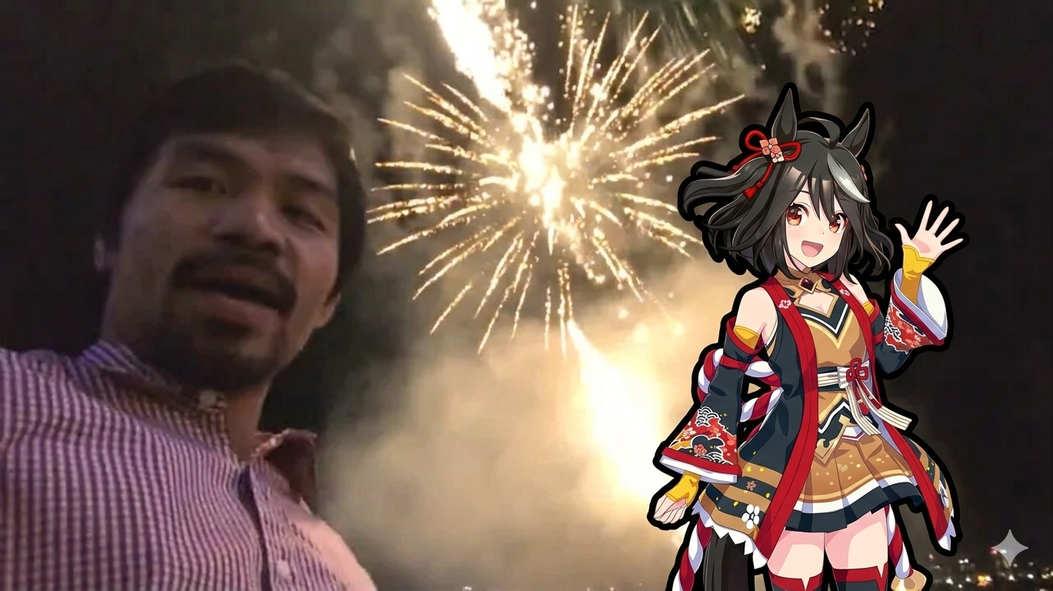

AI-ASSITED PROMPT
Gemini 3.1 Pro
Improved prompt
A composite image featuring a selfie of Manny Pacquiao in a red checkered shirt on the left side, with vibrant fireworks exploding in the night sky behind him. On the right side, place the anime girl character (Kitasan Black from Umamusume), but horizontally flipped so she is facing toward the center. Ensure she maintains her black outline and cheerful waving pose, blending naturally into the night-time firework scene.
Screenshot or copy of the new output
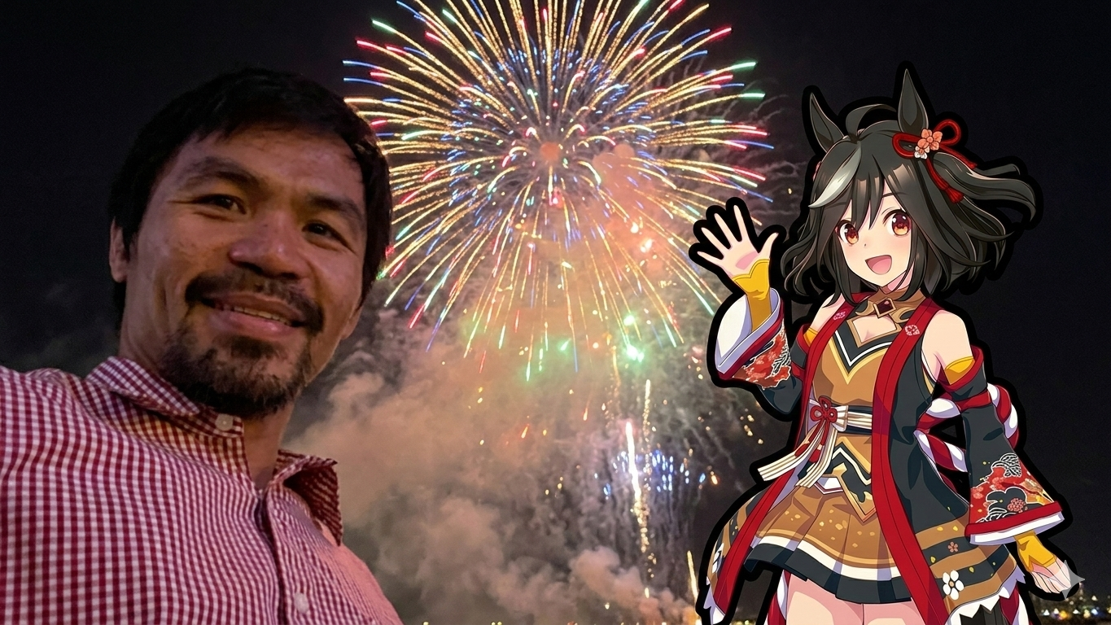

Comparison and Analysis
Reflection
The creation of this composite image serves as a fascinating exercise in digital surrealism, blending two entirely different cultural worlds: the grit of professional sports and the vibrant aesthetic of Japanese anime. At first glance, the pairing of legendary Filipino boxer Manny Pacquiao with Kitasan Black from Umamusume: Pretty Derby seems almost jarring, yet the final composition finds a strange, celebratory harmony through the shared backdrop of fireworks.
The technical process of the "improved prompt" was centered on establishing a cohesive visual narrative. By placing Pacquiao on the left, we anchor the image in a real-world "selfie" perspective, which creates an immediate sense of intimacy and presence. The fireworks act as the bridge between the two figures, providing a common lighting source and a thematic reason for both characters to be smiling and waving. This "celebration" motif effectively masks the fact that these two subjects would never naturally occupy the same space.
One of the most critical adjustments in the reflection of this process was the horizontal flip of the anime character. In the original asset, Kitasan Black was facing outward, which directed the viewer's eye away from the center of the frame. By mirroring her, we created a "compositional closed loop." Now, both subjects face toward the center, guiding the viewer’s gaze toward the focal point—the fireworks—and creating a sense of interaction between the real person and the fictional character.
Furthermore, maintaining the black outline on the anime girl was a deliberate stylistic choice. Rather than trying to force her to look "photorealistic," which often results in an uncanny valley effect, we leaned into the "sticker" or "AR filter" aesthetic. This acknowledges the artifice of the image while celebrating the intersection of different media. The result is a playful, modern piece of digital art that speaks to the way internet culture mashes up diverse interests—from world-class athletes to horse-girl idols—into a single, joyful moment of "what if?"

Appendix
Image used
